America Scores - Engineering Design

PRD: https://tinyurl.com/2pxmu2s5

## Context

The objective of this project is to create a student registration app which can be used to record student details by the student and which needs to be saved to salesforce for the coaches to access the student details while taking attendance.

## Solution

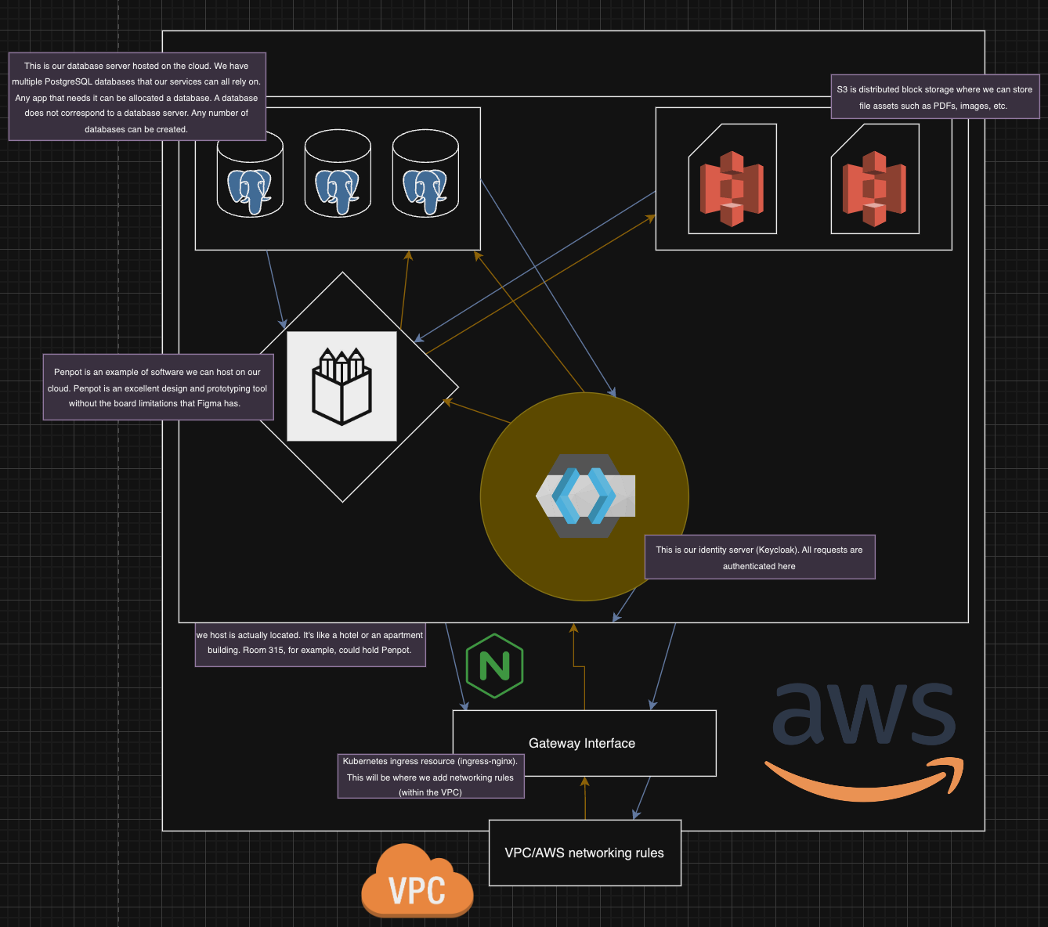

### Components

See above (descriptions are in purple boxes next to each component).

### DataStore

* PostgreSQL hosted on AWS RDS
* Redis self-hosted on EKS

### API Endpoints

* Registration API: [https://tinyurl.com/](https://tinyurl.com/bdd9f32h)<Some Link>

1. **Create Student Record:**
   * **Endpoint:** */api/students/create*
   * **Method:** POST
   * **Request Body:** { "firstName": "John", "lastName": "Doe", "school": "XYZ School", "parentPhone": "123-456-7890", "parentEmail": "john.doe@example.com" }
   * **Response:** This endpoint creates/saves the student details to Salesforce and returns a Student ID

* **Return Students Informations:**
  + **Endpoint:** */api/students/*
  + **Method:** GET
  + **Request Body:** { "students": [ "firstName": "John", "lastName": "Doe", "school": "XYZ School", "parentPhone": "123-456-7890", "parentEmail": "john.doe@example.com", ... ] }
  + **Response:** This endpoint return all students informations from Salesforce

* **Returns a Specific Student’s Details:**
  + **Endpoint:** /api/students/{id}
  + **Method:** GET
  + **Request Body:** { "firstName": "John", "lastName": "Doe", "school": "XYZ School", "parentPhone": "123-456-7890", "parentEmail": "john.doe@example.com" }
  + **Response:** This endpoint gets the specific student details from Salesforce
* **/api/enrollments/create** - This endpoint creates enrollment of a student for a team season
  + **Endpoint:** /api/enrollments/create
  + **Method:** POST
  + **Request Body:** { "studentID": "string", "teamSeasonID": "string" }
  + **Response:** This endpoint creates enrollment for the student
* **/api/enrollments/bulkcreate** - This endpoint creates enrollment of a student for a team season
  + **Endpoint:** /api/enrollments/bulkcreate
  + **Method:** POST
  + **Request Body:** [ { "studentID": "string", "teamSeasonID": "string" }, ... ]
  + **Response:** This endpoint creates enrollment for the two or more students
* **/api/teams/seasons** - This endpoint gets the team seasons details from Salesforce for a specific school site(ID)
  + **Endpoint:** /api/teams/seasons
  + **Method:** GET
  + **Request Body:** schoolSiteID: string is required
  + **Response:** This endpoint returns the team seasons available for a given school site.

### UX

Users of software hosted on DFG’s cloud can easily access and utilize it to enhance the projects they’re working on or are otherwise a part of.

## Assumptions

* There are a fixed number of students who are expected to attend each session.
* When we save a student record, The student is assigned an unique “ID”

## Limitations

## 

## Alternative solution considered / Justification

Using GCP instead of AWS was considered by Jenny and I because we initially tested things on GCP. However, we are confident that we can use AWS successfully and since DFG already has an organization AWS, this is the best solution.

## Open Questions

* Best way to declaratively deploy infrastructure (Terraform vs. CloudFormation)
* Best way to internally test the software